**Overview**

In this activity, you’ll practice a design challenge just like the one you might do during an interview.

Why? Because companies use design challenges to assess job candidates. With 30 minutes and a whiteboard, they can see how much you think like a designer.

## Instructions

**Part 1: Set Up Activity (5 min)**

1. Pair up with 1 other person.
2. Get a large sheet of paper or a large whiteboard space.
3. Apply the Canvas Template to your own paper/whiteboard space.

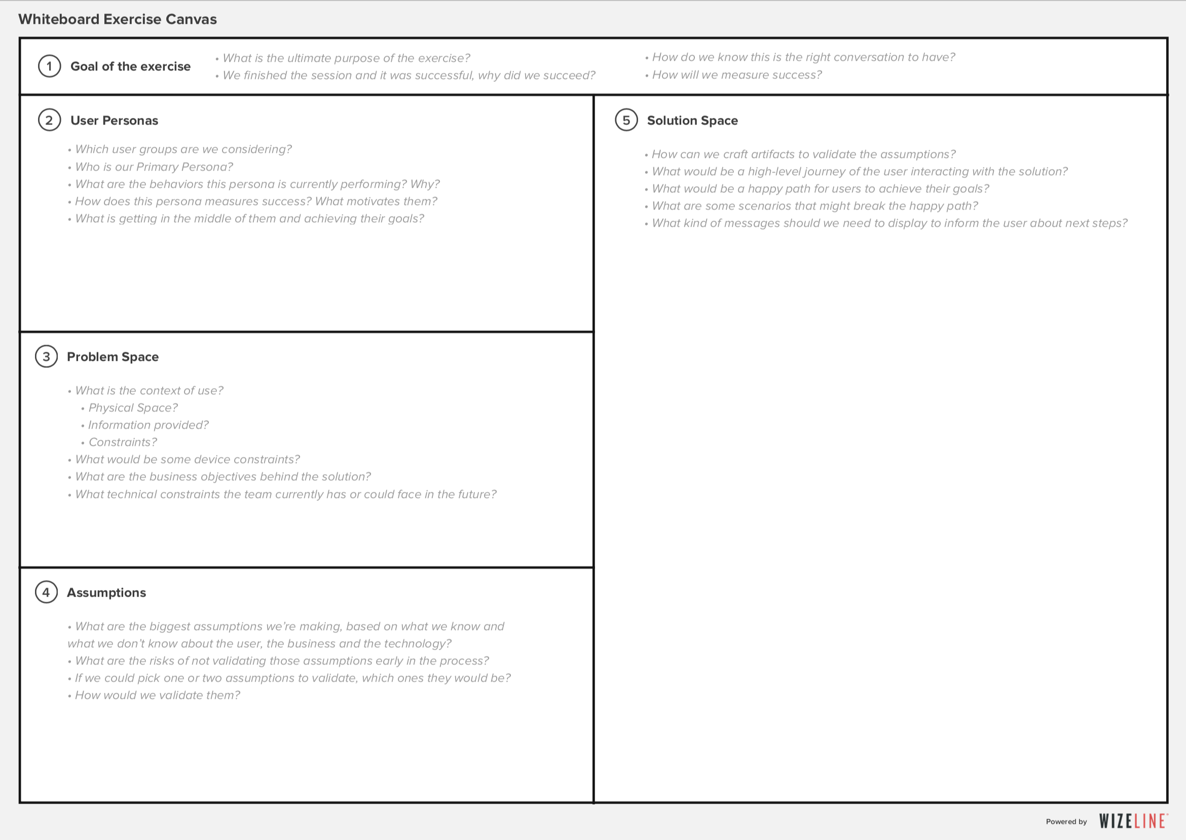

**Download the Template:**

[Wizeline Whiteboard Exercise Canvas Template](https://www.dropbox.com/s/kpqnlefgra67oak/Whiteboard%20Canvas.pdf?dl=0)

**Part 2: Complete the Design Challenge Canvas (45 min)**

1. You will work through the challenge with your partner.
   * Set a 45-minute timer.
2. Here is the Design Challenge Prompt—read it through carefully:

**Design Challenge Prompt: Create personalized audiobooks.**Audiobooks and podcasting are the fastest-growing audio segments on mobile with Gimlet Media, This American Life, and 99% InVisible.   
  
Users who listen to audiobooks don’t enjoy the benefits of dog-earing pages, highlighting excerpts, or leaving notes on their favorite pages. They also lose the nostalgic aspects of owning a book and watching it age. This leaves a lot to be desired from the audio experience on mobile.

Design an audiobook or podcasting mobile app that is highly personal, highly interactive, and with the ability to bring even more utility to the user than a book ever could.  
  
*Constraint: All suggested technologies need to exist or have the ability to exist realistically within the next six to 12 months.*

1. Complete all sections of the canvas.
   * Be mindful of the time.
   * Work through each step of the framework.
2. When you complete the challenge, request a review from one of the instructional staff.
3. If you finish up early, consider solving for the following prompt:

**Design Challenge Prompt:** **Design a mobile app for a coffee machine.**

In America, coffee is a huge business. Coffeebot is a startup that aims to make it as easy as possible to drink the best-tasting cup of coffee at home. They want to create a coffee machine that syncs with a mobile app using Bluetooth so you can control exactly how you like your coffee.

Design a mobile app for the coffee machine described above.

**Part 3: Take a Photo and Share in Slack**

1. Take a photo of your work with your partner.
2. Share the photo in Slack.

**In the Real World**

As you wrap up, remember that the more people you share your design challenge with, the better your work will be. Feedback will help you fine-tune your solution and improve how you talk about your thinking. Design challenges are supposed to make you think and maybe even stump you. The goal is to be able to quickly communicate and show how you think and why you have the tenacity to be a good team member when solving more significant problems on the job.